**Assignment:2**

* **Problem Statement:** Create MFA for authentication
* Steps:

1. Log into AWS account and go to security credentials.

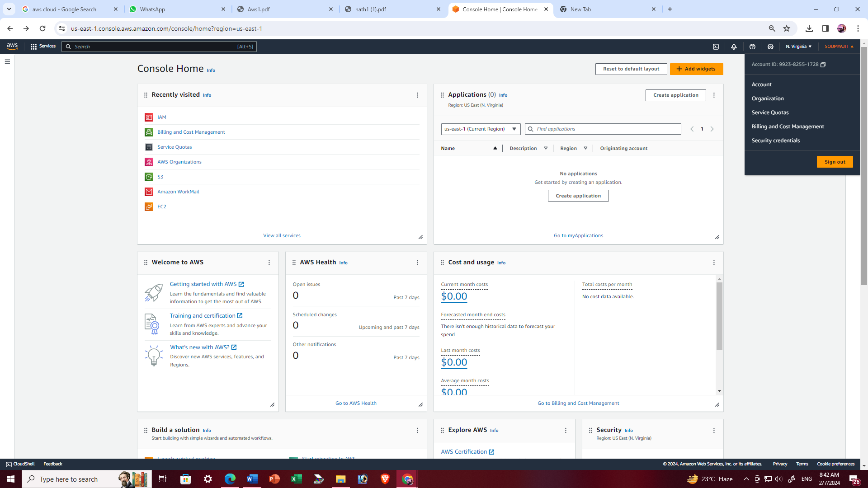

1. Click on ‘Assign MFA device’.

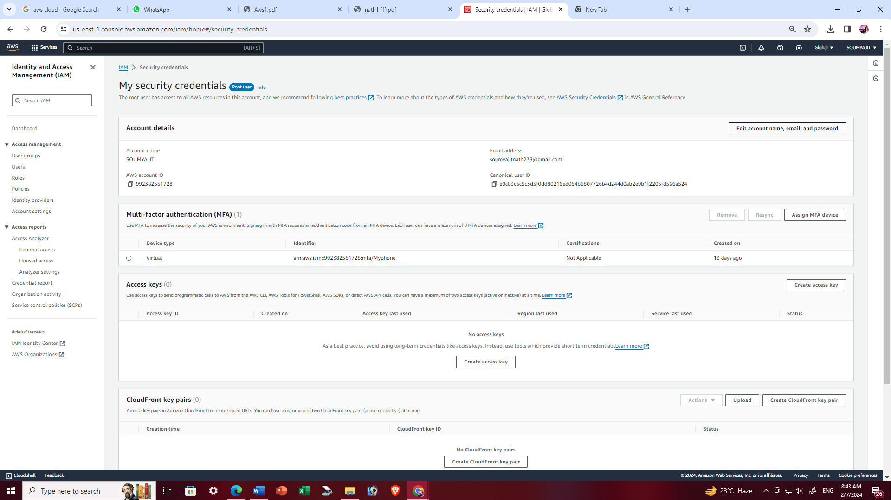

1. Enter MFA device name and click on ‘Next’.

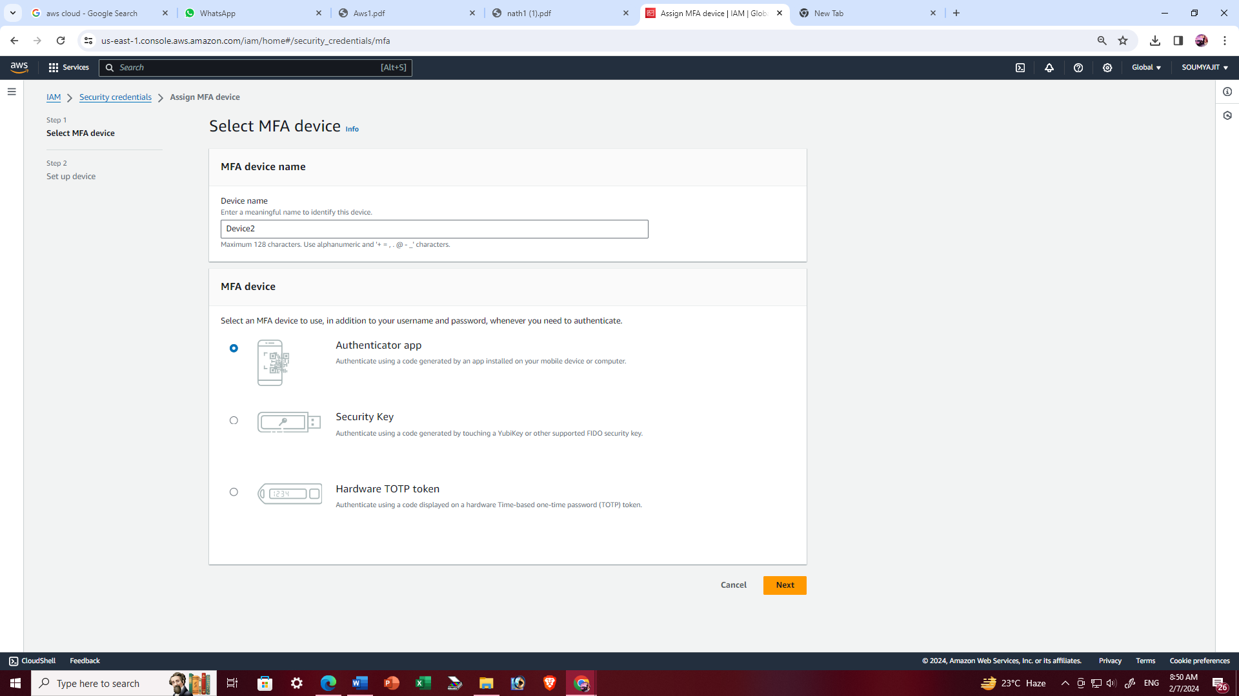

1. Enter code using authenticator app and click on ‘Add MFA’ to complete the process.

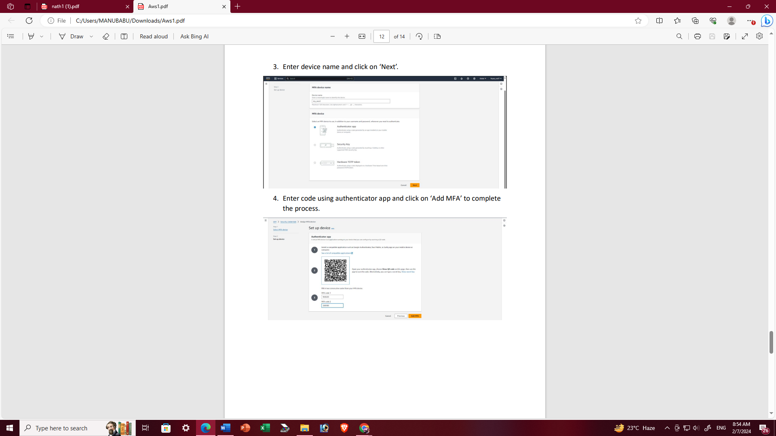

1. MFA device assigned successfully

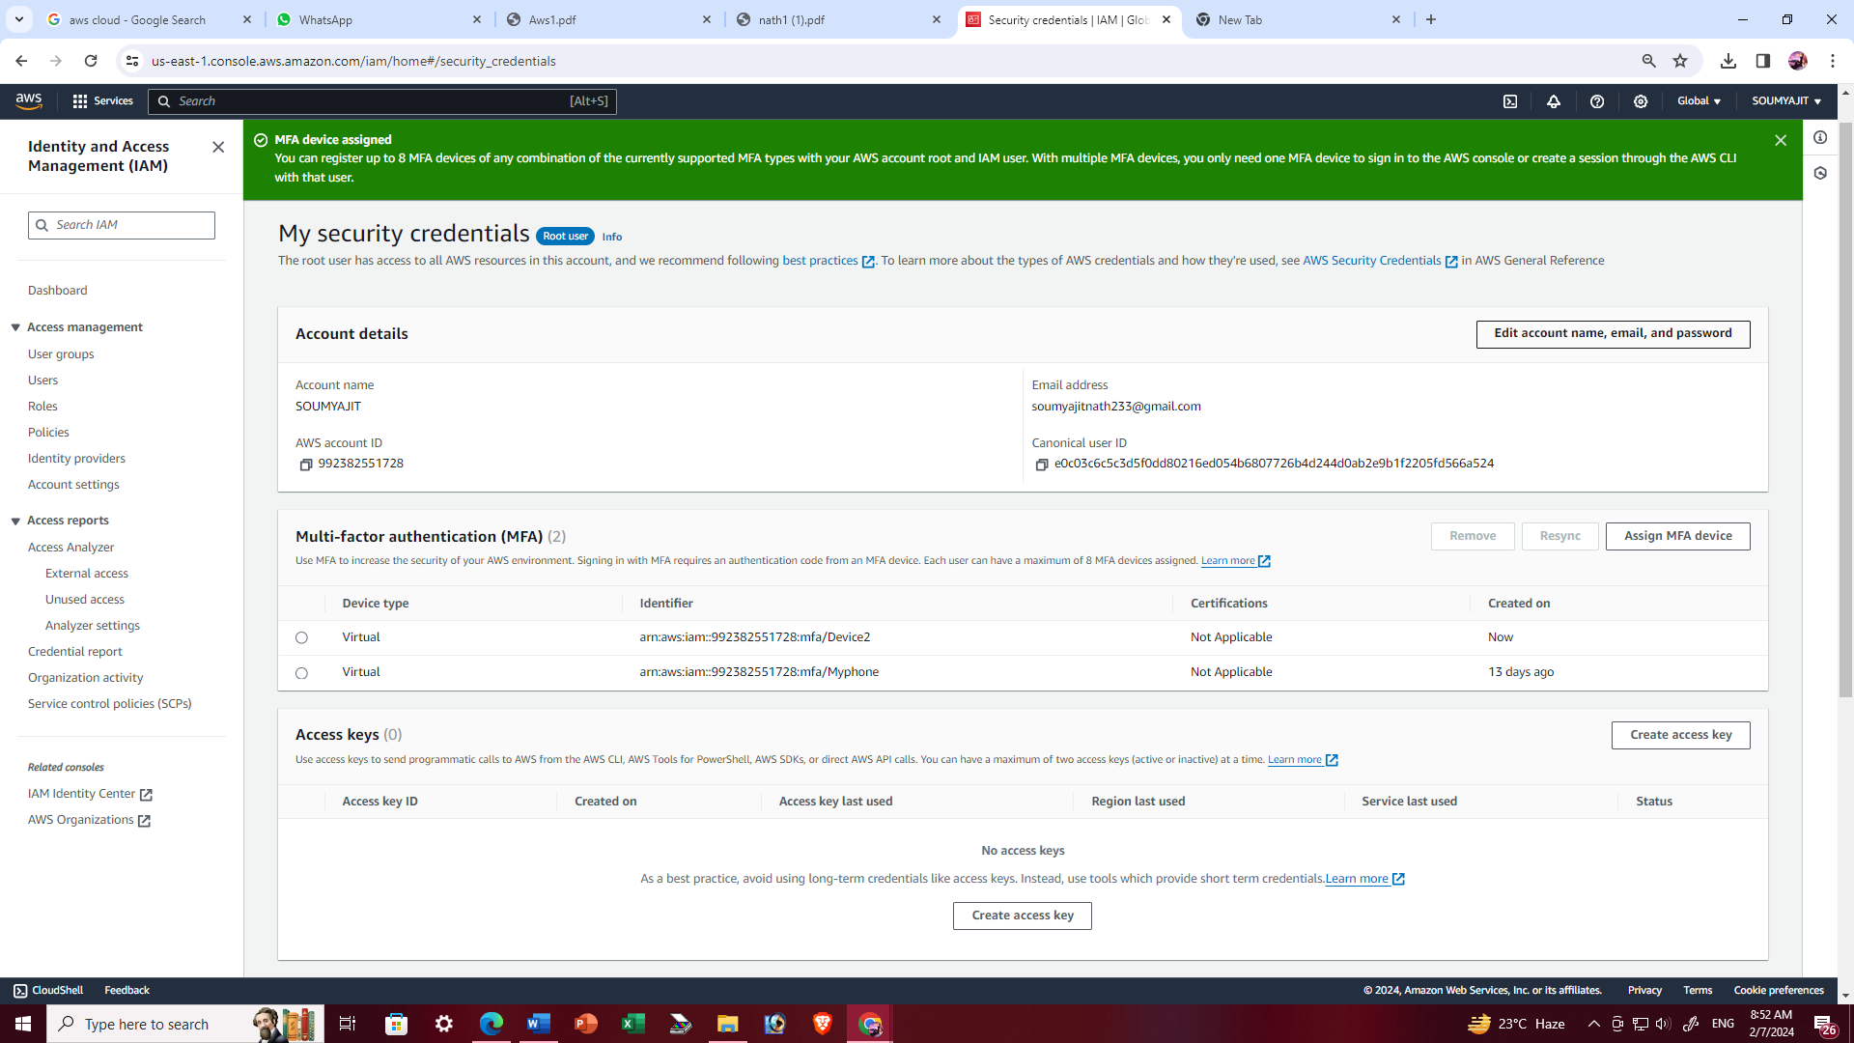

1. Login to the aws account using MFA code and click submit then log in successfully.

